# Using Git in PHPStorm

This link illustrates every detail on how to use Github in PHPStorm. Though I’m picking some of the major points:

**Create a GitHub repository:**

Once our project is ready to be published on GitHub, we can use the **VCS** -> **Import into Version Control** -> **Share project on GitHub** menu item to start publishing the project.

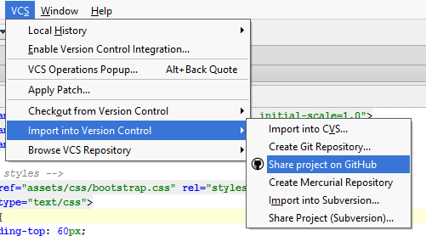

PhpStorm will then ask us to provide a repository name and description. After doing that, click the Share button. Suppose, our project name is phpTest. And with this name, we will create the new repository on Github.

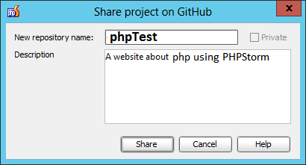

That’s it! Our project is now available on GitHub and we haven’t left our IDE!

## Clone a GitHub repo

Now what if we want to Clone our existing repository from Github!

From the VCS menu, we can use the Checkout from Version Control -> GitHub. This will fetch a list of all repositories that we can access using our account and allows us to clone those into a PhpStorm project:

[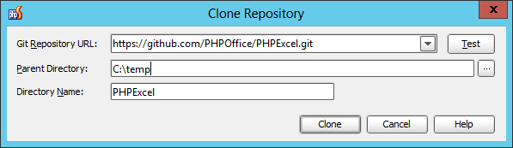](http://blog.jetbrains.com/webide/files/2013/01/05-clonefromgithub.png)

Click the dropdown list and see all of your repositories. Select any one and Clone.

After clicking the Clone button, we’ll have the entire repository contents available locally and can code away. Once finished, simply use the traditional Git commands from the VCS menu.

Helpful Links:

1. http://blog.jetbrains.com/webide/2013/02/using-github-without-leaving-phpstorm/
2. http://blog.jetbrains.com/webide/2013/01/version-control-systems-support-basic-concepts/

# Using FTP in PHPStorm

To seamlessly up- and download files to and from your server, you're going to want to set up a deployment configuration with a **mapping** between a local and a remote folder. Here is how:

* Open the deployment configuration window by selecting **Tools** → **Deployment** → **Configuration...** from the menu.

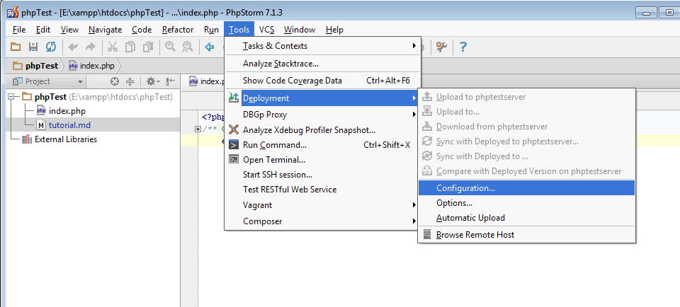

* If you haven't already created a deployment connection, create one one. I have already created one here and switched the **Mappings** tab.

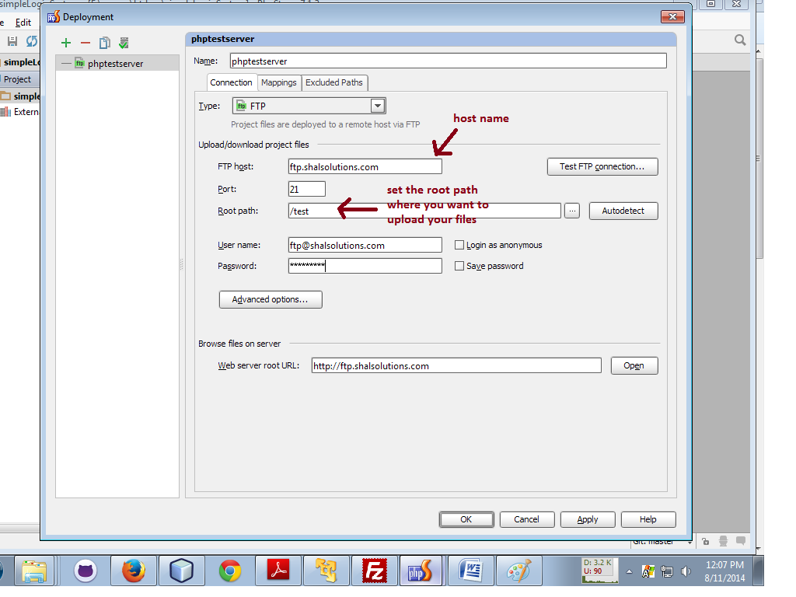

* Then click on the Mappings Tab.

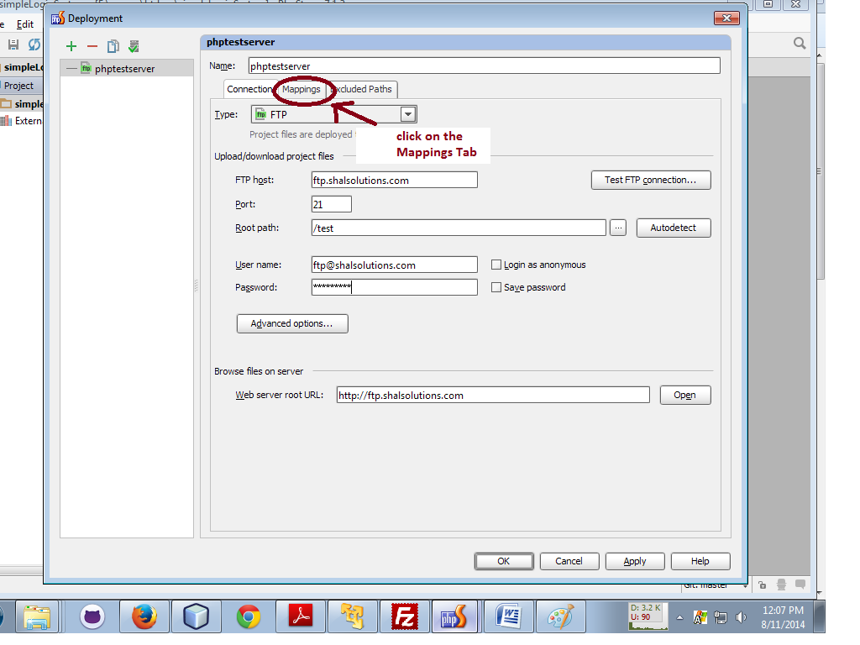

* Now, if you already set the root path, then use only ‘/’ in both fields.

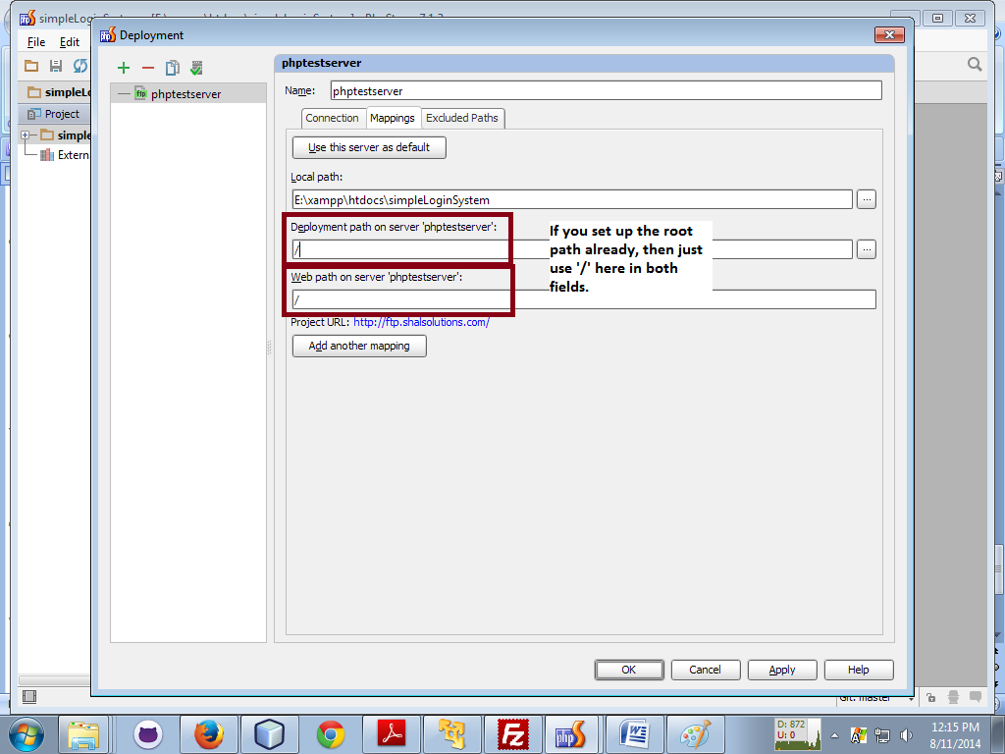

* Now, you can upload files right from your PHPStorm editor by right-clicking on the file.

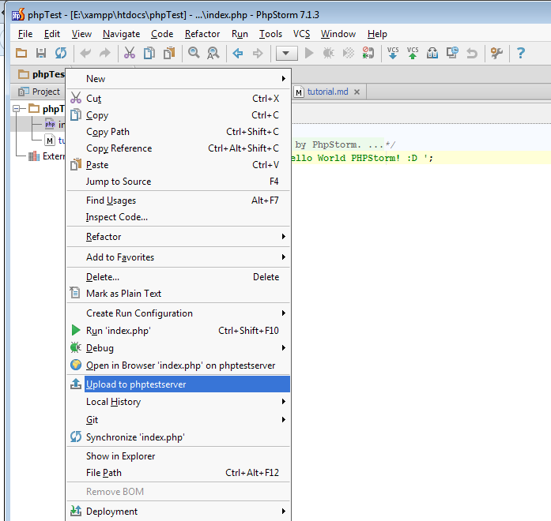

It’s pretty easy.

Now to download from Server, Go to Tools -> Deployment -> Browse Remote Host

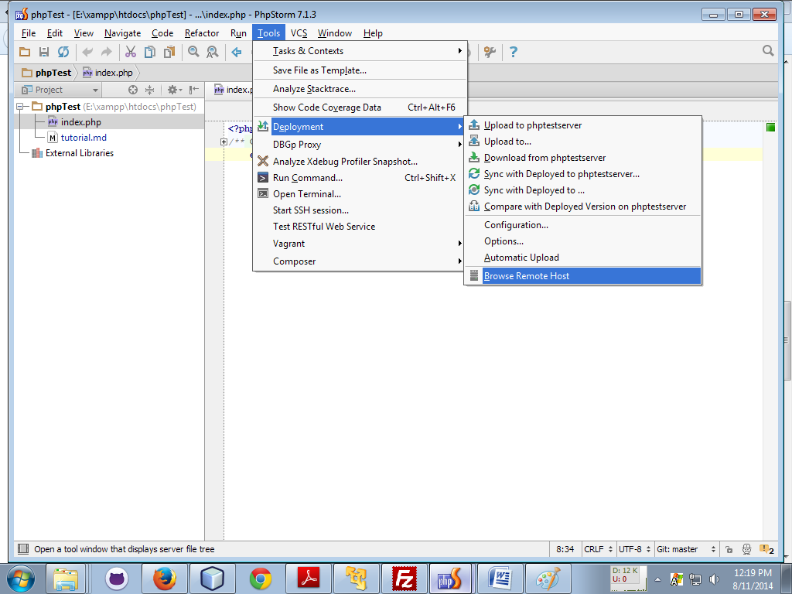

In the **Remote Host** panel, you'll now be able to download files to your project folder.

Hope, From now on we can use Github & FTP with PHPStorm, without leaving our editor :D

Helpful Link:

<http://superuser.com/questions/687490/how-to-download-files-in-ftp-using-phpstorm>